<Image Gallery Software>

Use-Case Specification: <Forgot Password>

Version <1.0>

Revision History

|  |  |  |  |
| --- | --- | --- | --- |
| **Date** | **Version** | **Description** | **Author** |
| <dd/mmm/yy> | <1.0> | <details> | Nguyen Kiem Hoa |
|  |  |  |  |
|  |  |  |  |
|  |  |  |  |

Table of Contents

1. Forgot Password 4

1.1 Brief Description 4

1.2 Actor 4

2. Flow of Events 4

2.1 Basic Flow 4

3. Special Requirements 4

4. Preconditions 4

5. Postconditions 4

6. Extension Points 4

Use-Case Specification: <Forgot Password>

# Forgot Password

## Brief Description

This use case defines the steps of retake password when user forgot their password. User can easily retake password with some simple steps.

## Actor

User

# Flow of Events

## Basic Flow

User need click on ‘Forgot password’ label at login form and an retake password form appear. Then, user need fill all necessary information and click get password. After that, an message contain password will be sent to user.

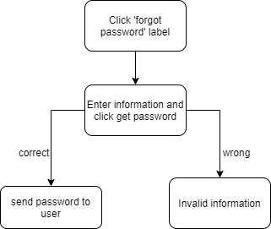

# Special Requirements

Click ‘forgot password’ from login form.

# Preconditions

Fill correct information

# Postconditions

Correct password is sent to user.

# Extension Points

No extension point.